Puppet agent

Error: Could not retrieve catalog from remote server: Error 400 on SERVER: Evaluation Error: Error while evaluating a Resource Statement, Evaluation Error: Error while evaluating a Function Call, Duplicate declaration: File[/opt/fedex/ground/ssm/setup-ssm-keys.sh] is already declared; cannot redeclare at /etc/puppetlabs/code/environments/production/modules/fdx_ground/manifests/scmsupport.pp:22:5 on node c0010266.test.cloud.fedex.com

Warning: Not using cache on failed catalog

Error: Could not retrieve catalog; skipping run

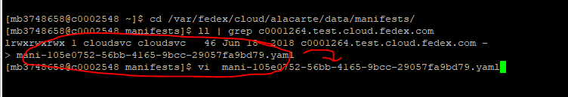

#cd cd /var/fedex/cloud/alacarte/data/manifests/

# ll | grep (server name)

# vi (server name) ---- remove the software that are in the error along with that, remove that software in the UI as well in the software tab.